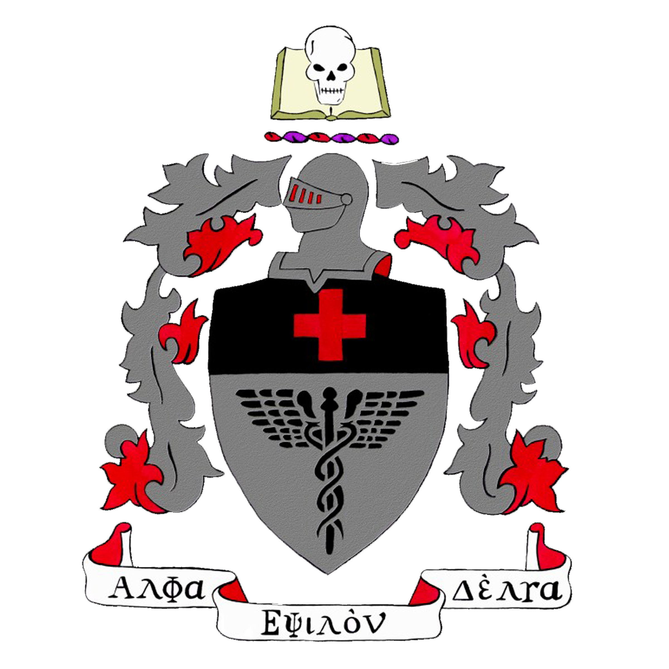
Dinner with a Doctor R.S.V.P. FORM

NAME:
PLEASE PRINT

AED NEW MEMBER HONORARY EVENT
Tuesday, February 17, 2020
Arkansas Union Ballroom
435 N Garland Avenue
Fayetteville, Arkansas 72701
6:00 PM

As an initiate of AED, I understand that I must attend the Dinner with a Doctor on
Tuesday, February 17, 2020 at 6:00 PM at the Arkansas Union Ballroom.

If I have a laboratory class, I will pre-arrange to complete the laboratory in the same week on another day.

I have read and understand the above information:

SIGNATURE:

DATE:

