Alpha Epsilon Delta T-Shirt Form

Design: Sourced from Houndstooth Press in Graphite
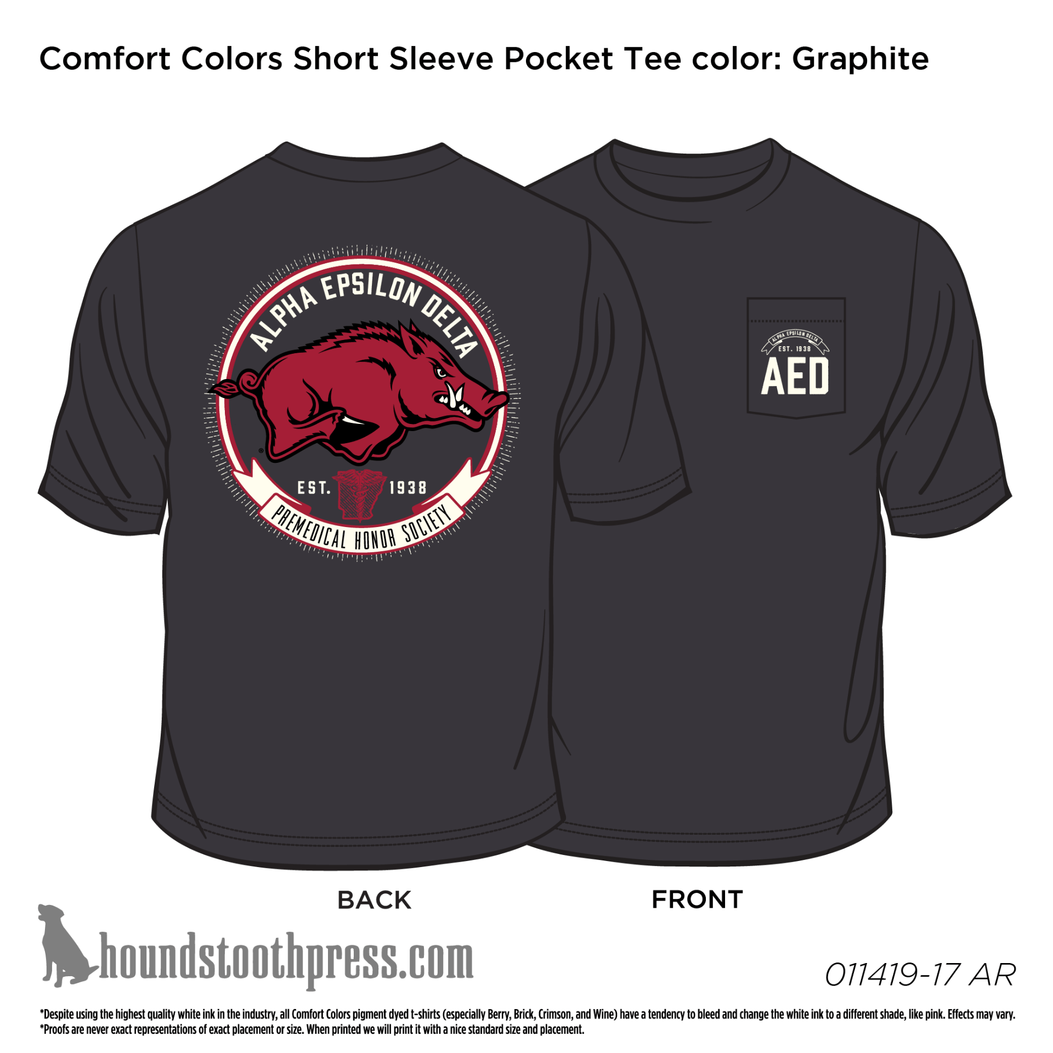

Name: ______________________________________________
PLEASE PRINT
Sizes: Please Check One
S
M
L
XL
XXL
Payment: $17 (S-XL), $19 (XXL) By Check
(THIS MUST BE A CHECK FOR ONLY THE COST OF THE T-SHIRT. If you are applying for AED Membership also, do not include this t-shirt cost within the same check as your membership fee. Please write separate checks.)
Signature: ___________________________________________
Date: _______________________________________________

